

***AMERICAN INTERNATIONAL UNIVERSITY-***

***BANGLADESH***

where leaders are created

**Project Name** : **Art Gallery Management System**

**Course**  : **Introduction To Database**

**Section** : **K**

**Faculty** : **Rifat Tasnim Anannya**

**Semester** : **Fall 20-21**

**Program** : **BSc in CSE**

**Group Members:**

|  |  |
| --- | --- |
| **Name** | **ID** |
| FAHIMA MAHJABIN MIM | 20-42231-1 |
| FARIHA TAHSEEN KARIM | 20-43289-1 |
| ABDULLAH AL SOAD | 20-43425-1 |
| ABU JUBAIR BIN AMIN | 20-43583-1 |

**Art Gallery Management System**

* **Scenario:**

The art gallery system intends to include various features related to an art gallery i.e. information about exhibition, artists, their paintings, customers, etc. The main aim is to help art lovers know about different exhibitions organized by the admin. Customers will directly take part in an exhibition to see the exquisite arts and if they like any of them, they will purchase it by paying the suitable cost or by bidding in the auction. To enhance the beauty of this art gallery, various categories of artwork i.e. different types of paintings, sculptures, etc. are displayed in the exhibition. Admin plays a vital role by using this application to give access to the customers who want to place orders. The admin also manages the artists whose paintings are available. This system provides people with the facility to contact the artists if they wish to learn from them.

* **E-R Diagram:­**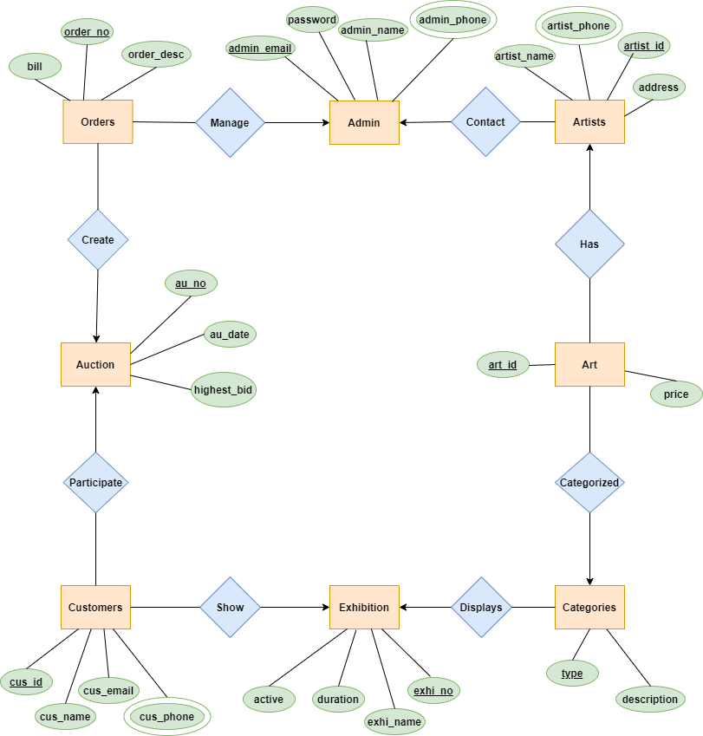

**Normalization**

* **Contact-**

(admin_email, password, admin_name, admin_phone, artist_id, artist_name, address, artist_phone)

**1NF** - admin_phone and artist_phone are multi-valued attributes

**2NF** - admin_email, password, admin_name, admin_phone  
 artist_id, artist_name, address, artist_phone

**3NF** - There is no transitive dependency.

**Tables for Contact-**  
 1. admin_email, password, admin_name  
 2. admin_email, admin_phone  
 3. artist_id, artist_name, address, admin_email  
 4. artist_id, artist_phone

* **Has-**

(artist_id, artist_name, address, artist_phone, art_id, price)

**1NF** - artist_phone is a multivalued attribute

**2NF** - artist_id, artist_name, address, artist_phone  
 art_id, price

**3NF -** There is no transitive dependency.

**Table for Has-**  
 1. artist_id, artist_name, address   
 2. artist_id, artist_phone  
 3. art_id, price, artist_id

* **Categorized-**

(art_id, price, type, description)

**1NF** - There is no multi-valued attributes

**2NF** - art_id, price  
 type, description

**3NF** - There is no transitive dependency.

**Table for Categorized-**  
 1. type, description   
 2. art_id, price, type

* **Displays-**

(type, description, exhi_no, exhi_name, duration, active)

**1NF** - There is no multi-valued attributes

**2NF** - type, description  
 exhi_no, exhi_name, duration, active

**3NF** - There is no transitive dependency.

**Table for Displays-**  
 1. exhi_no, exhi_name, duration, active   
 2. type, description, exhi_no

* **Show-**

(cus_id, cus_name, cus_email, cus_phone, exhi_no, exhi_name, duration, active)

**1NF** - cus_phone is a multi-valued attribute

**2NF** - cus_id, cus_name, cus_email, cus_phone  
 exhi_no, exhi_name, duration, active

**3NF** - There is no transitive dependency.

**Table for Show-**  
 1. cus_id, cus_name, cus_email, exhi_no  
 2. cus_id, cus_phone  
 3. exhi_no, exhi_name, duration, active

* **Participate-**

(au_no, au_date, highest_bid, cus_id, cus_name, cus_email, cus_phone)

**1NF** - cus_phone is a multivalued attribute

**2NF** - au_no, au_date, highest_bid  
 cus_id, cus_name, cus_email, cus_phone

**3NF** - There is no transitive dependency.

**Table for Participate-**  
 1. au_no, au_date, highest_bid   
 2. cus_id, cus_name, cus_email, au_no  
 3. cus_id, cus_phone

* **Create-**

(order_no, bill, order_desc, au_no, au_date, highest_bid)

**1NF** - There is no multi-valued attributes

**2NF** - order_no, bill, order_desc  
 au_no, au_date, highest_bid

**3NF** - There is no transitive dependency.

**Table for Create-**  
 1. order_no, bill, order_desc, au_no  
 2. au_no, au_date, highest_bid

* **Manage-**

(admin_email, password, admin_name, admin_phone, order_no, bill, order_desc)

**1NF** - admin_phone is a multi-valued attribute

**2NF** - admin_email, password, admin_name, admin_phone  
 order_no, bill, order_desc  
**3NF** - There is no transitive dependency.

**Table for Manage-**  
 1. admin_email, password,admin_name   
 2. admin_email, admin_phone  
 3. order_no, bill, order_desc, admin_email

* **Total Table-**

1. admin_email, password, admin_name – Admin
2. admin_email, admin_phone – Admin2
3. artist_id, artist_name, address, admin_email – Artist
4. artist_id, artist_phone – Artist2
5. art_id, price, artist_id, type – Art
6. exhi_no, exhi_name, duration, active – Exhibition
7. type, description, exhi_no – Categories
8. cus_id, cus_name, cus_email, exhi_no, au_no – Customer
9. cus_id, cus_phone – Customer2
10. au_no, au_date, highest_bid – Auction
11. order_no, bill, order_desc, au_no, admin_email – Orders

**Screenshots – (table desc)**

**[ Desc Table_name ]**

* Admin

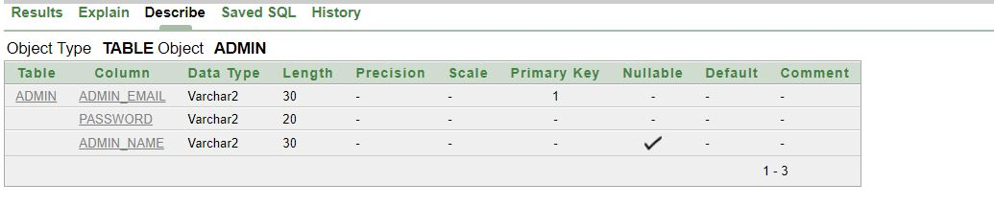

* Admin2

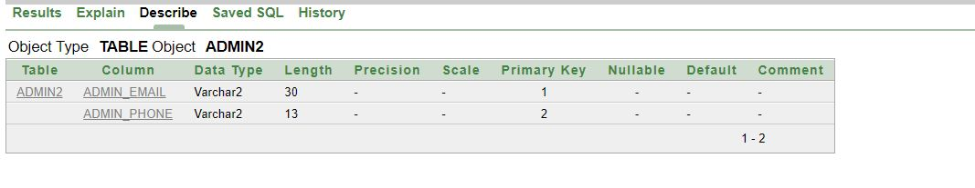

* Artist

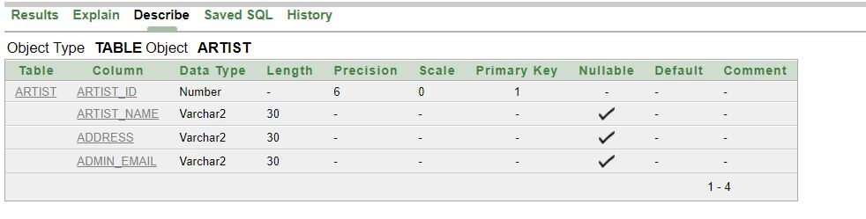

* Artist2

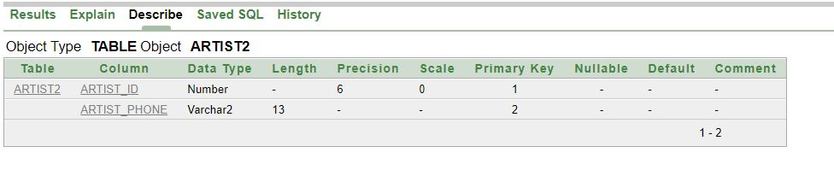

* Art

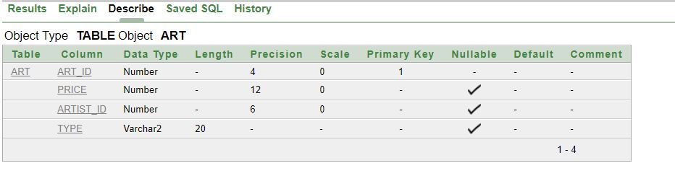

* Exhibition

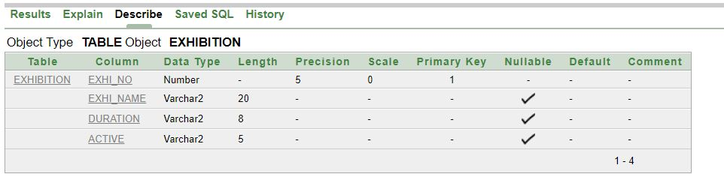

* Categories

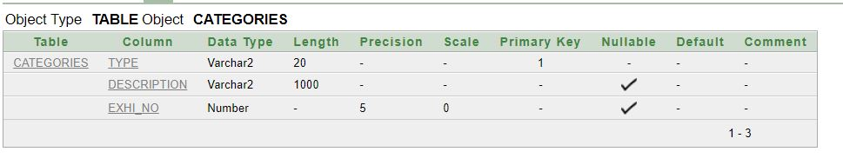

* Customer

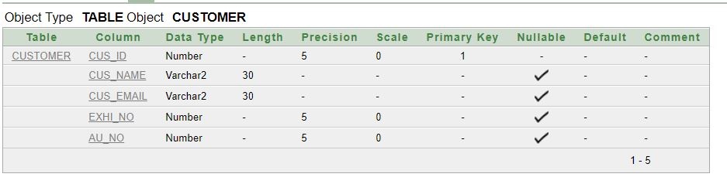

* Customer2

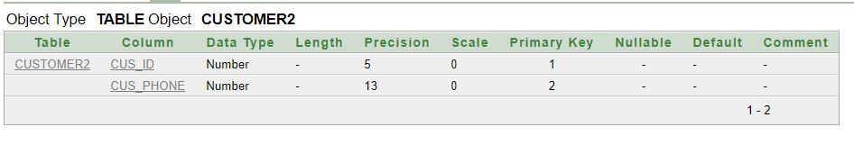

* Auction

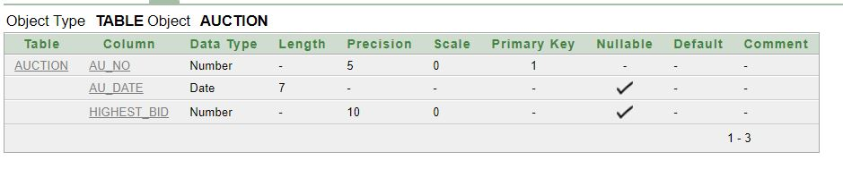

* Orders

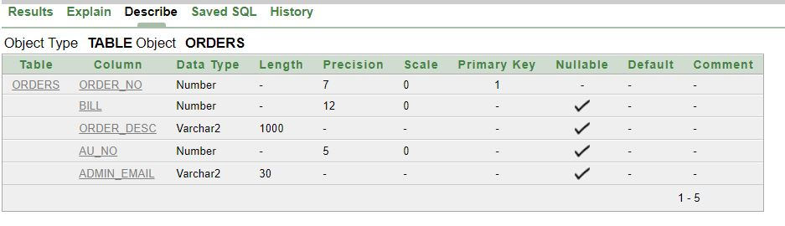

**Screenshots – (value)**

**[ Select * from table ]**

* Admin

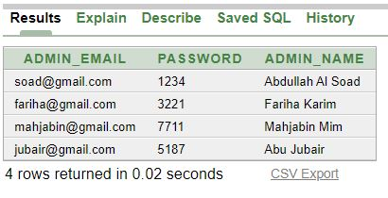

* Admin2

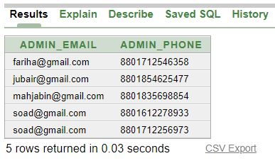

* Artist

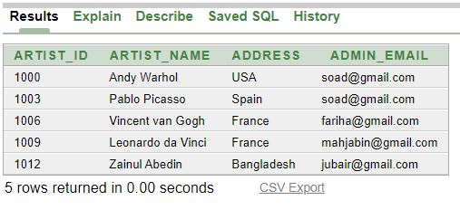

* Artist2

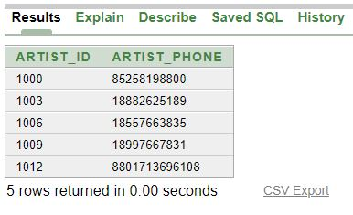

* Art

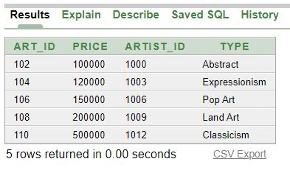

* Exhibition

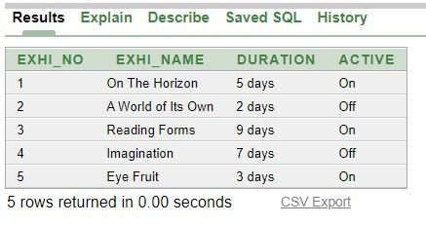

* Categories

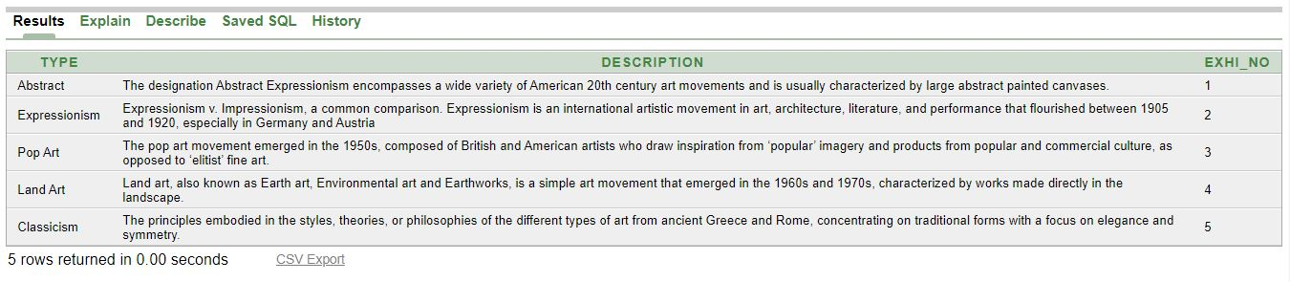

* Customer

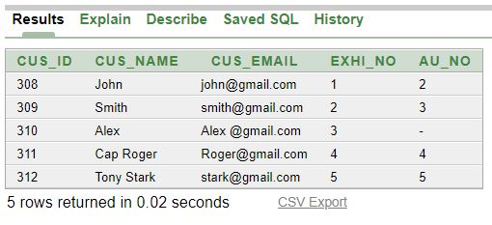

* Customer2

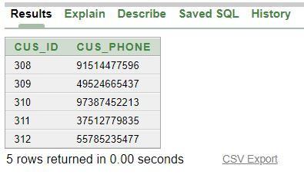

* Auction

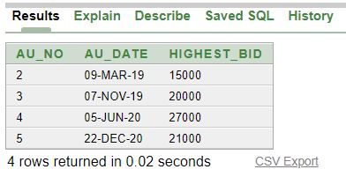

* Orders

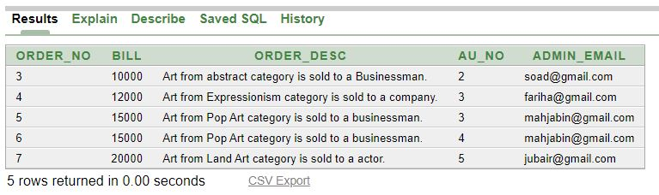

**Screenshots – (using constraints)**

**[ Select * from all_constraints where table_name='TABLE' ]**

* **Check-**

**Art**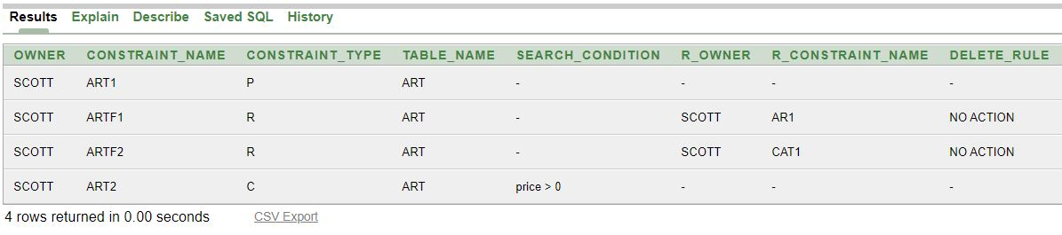

**Exhibition**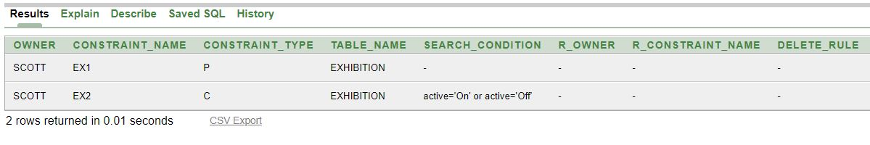

* **Is not NULL-**

**Admin**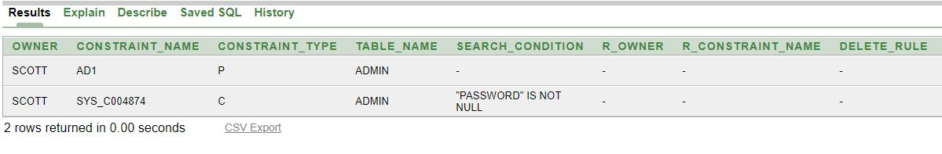

* **Unique-**

**Customer**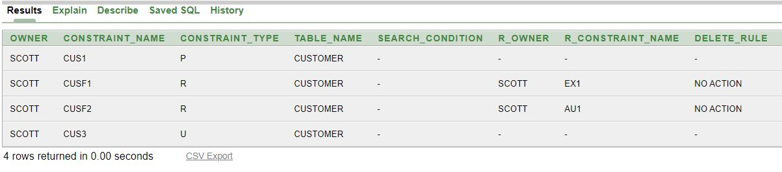

**Screenshots – (foreign key)**

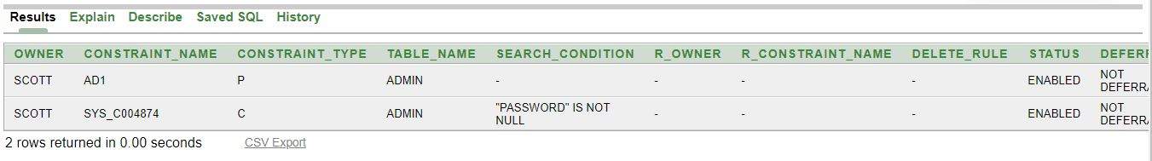

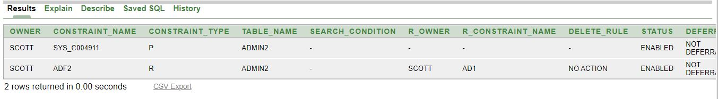

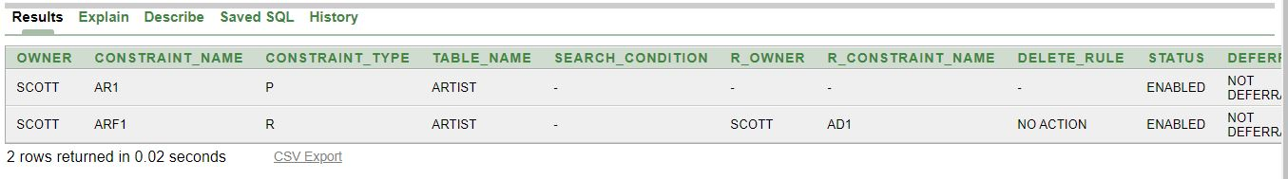

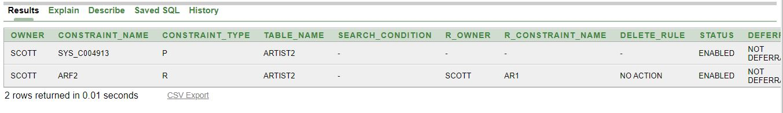

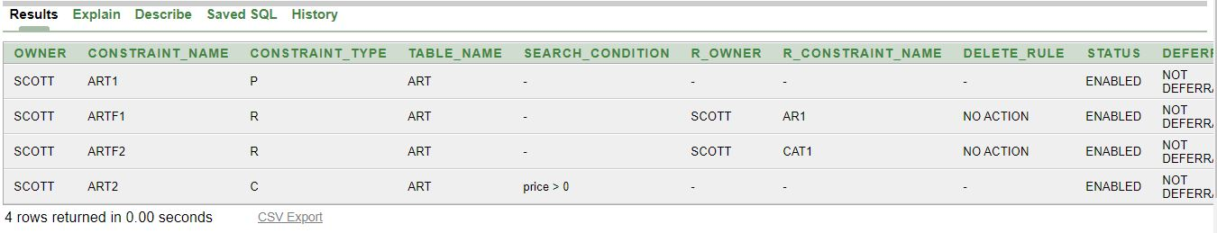

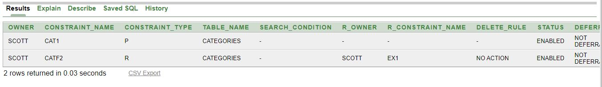

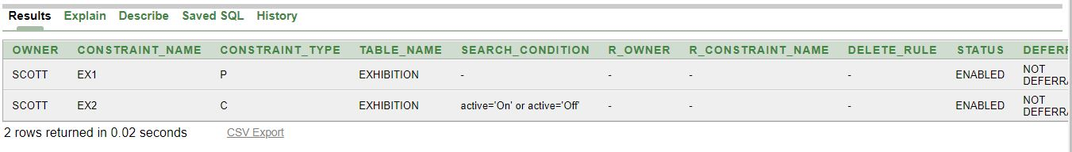

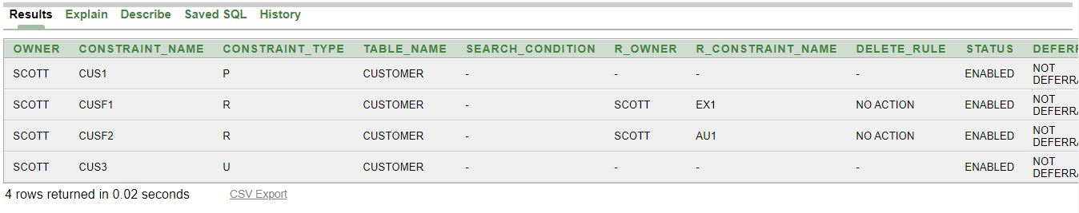

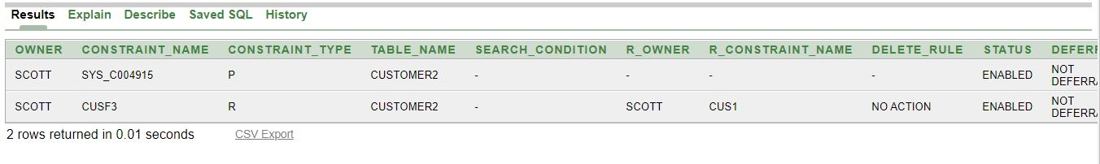

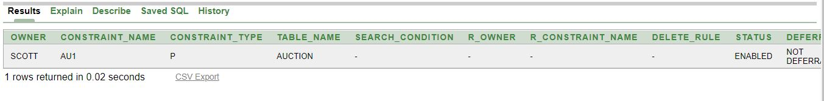

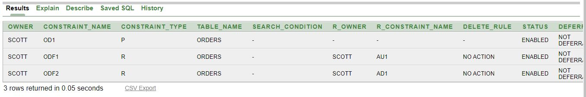

Questions

**SingleRow-**

1. Display the name of the customers whose name starts with the first letter J.
2. Write a query to display the art type which price is between 110000 and 200000.

**SubQuery-**

1. Display the type of art along with the artist id of the least expensive art.
2. Display the artist_id, artist name who's address is same as Leonardo da Vinci. (Exclude Leonardo da Vinci)

**GroupFunction -**

1. Display all the customers who are currently in an active exhibition and are going to the auction center.
2. Write a query to display all Exhibition names which duration is higher than the duration of “On The Horizon” and sort the result on duration from highest to lowest.

**Join-**

1. Display a list of Artists with their arts price and description.
2. Write a query to display customer name, exhibition name, duration and whether it is active or not for the customer who attended the exhibition number 4.

**Sequence-**

1. Alter the sequence order_sq increment by 5 and make the sequence cycle with minvalue 10 and cache should be 20.

**View-**

1. Using your view ‘A_test’, enter a query to display all the art prices and artist ids.